The “90° Rule” Theory
Written by: Jason Owens
Jdo300@sbcglobal.net
September 18th 2005

In this document, I will be presenting my findings with what I call the 90 degree rule. My conclusions are based on my own personal experiments and observations, as well as simulated data, patents, and information presented by Tom Bearden relevant to the subject.

The 90 degree rule is derived from a simple principle I have been using for quite some time. I call it the Tri-Force Theory and here is a diagram representation of it:

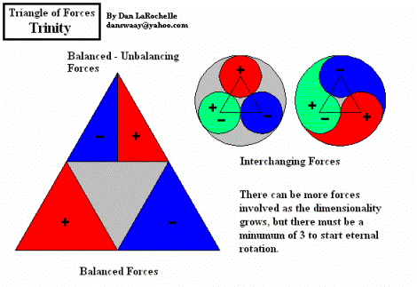
This concept is originally proposed by Dan LaRochelle and has proved to be very useful in guiding my magnet motor designs. The tri-force principle states that in order to have a functioning magnet motor, there must be a combination of attraction, repulsion, and superimposition (balancing) of forces. Now, by itself, the tri-force principle does not explain specifically how to design and engineer a specific magnet motor but it will give designers of such, constraint to follow. I have been attempting to apply this principle to my design ideas but as I’ve worked, and read more, I’ve come to realize there is really a lot more to magnets than what meets the eye.

At the time, I was trying to apply the Tri-Force principle to a new magnet motor I called the Tri-Phase motor. It was supposed to use the combination of attraction, repulsion, and balancing to accomplish my goal of a running motor. The design was based on Mike Brady’s Perendev motor and my basic goal was to simplify the design. However, as I worked with the tri-phase design, I discovered what I now call the 90 degree rule.

The 90 degree rule is an extension of the tri-force principle. It is what I believe to be the missing piece of the puzzle for a working magnet motor. The basic idea can be summed up using the following diagram:

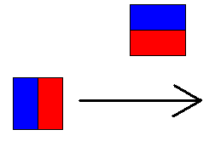

Visualize the bottom magnet on a moving rotor disk and the top magnet as part of a fixed, stator assembly. As they pass each other going from left to right there is a weak repulsive force followed by a violent ‘kick’ that pushes the magnets past each other. I have both simulated and personally tested this principle and have proven it to work. Here is a graph I produced in the FEMM magnetic simulator of this arrangement:

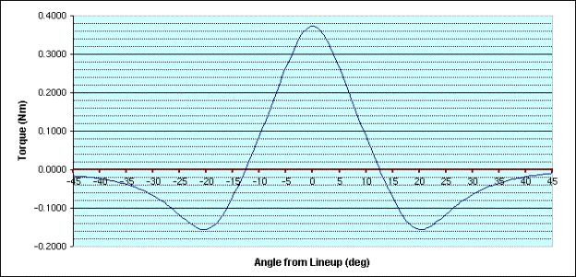

And here is a picture from the lever test I performed to prove this principle:

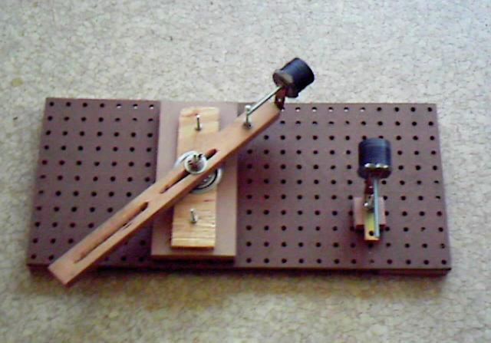

I also made a video of the arm ramp test here (the link points to an 8 mb video clip, best thing to do (or when the clip doesn't run) is a right-click with the mouse and save the target) for those interested. I highly recommend that everyone who reads this try the test. It is an excellent way for each person to see and feel the forces that are in action.

As further evidence for the principle, I did a bit of patent searching to see if there were any similarities in various magnet motor designs. I sent some screenshots of different designs to Eric Vogels, and he uploaded them to a page where you can see here:

/otherwheels/patents.asp?URL=patents.asp

You may notice there are some similarities between the different designs, but the major thing I want you to see is that all of them implement the 90° rule in some form or another. You can also see similar arrangements of magnets in the Howard Johnson Motor:

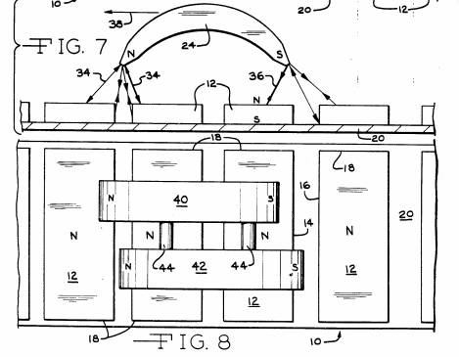

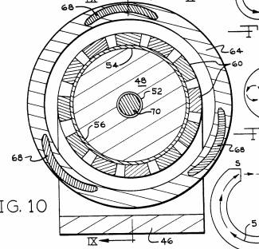

And the famous Bowman Motor--

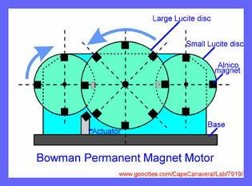

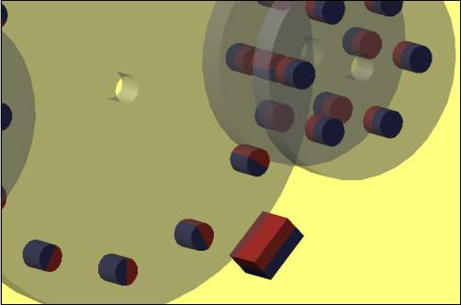

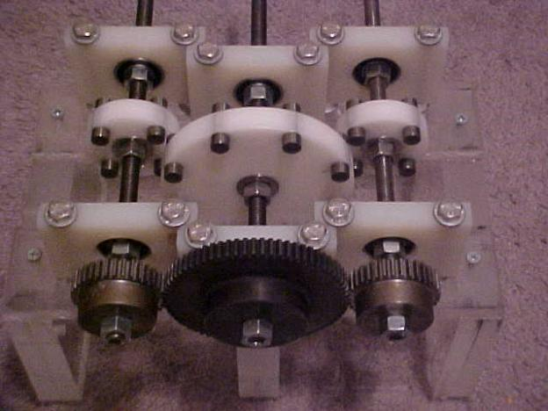

which appears to be derived from this original design invented by Peter Peregrinus way back in 1269 A.D:

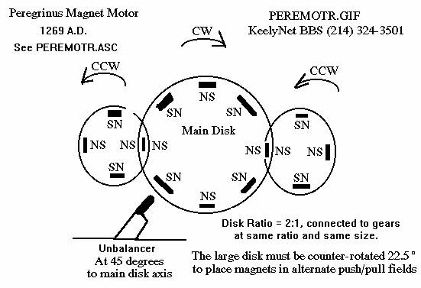
That 45 degree magnet has its North Pole facing towards the rotor disk.... Again the 90 degree rule crops up.

But I can’t forget about the famous TOMI motor either, that is perhaps the most classic example of all:

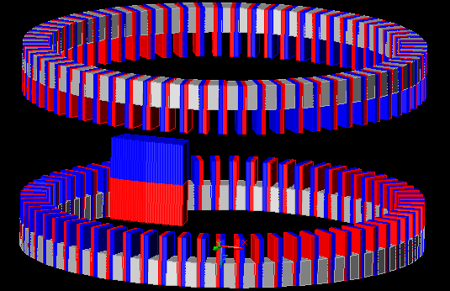

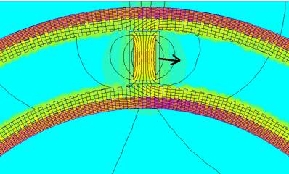

If I may throw in one more example here, I’ll add the Minato wheel as well:

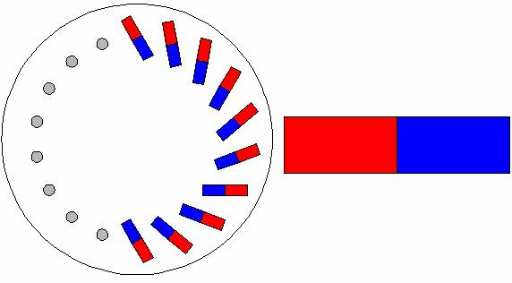

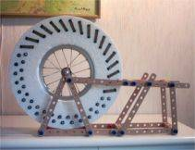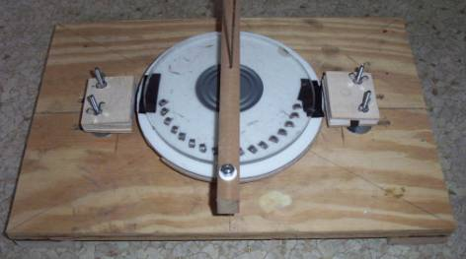

Even though in this case the effect is less obvious, the same thing is taking place… the 90 degree rule is in effect all over the place!

So after reaching these realizations, I thought I’d figure out what’s really going on with these magnets. Where does that mysterious ‘kick’ force really come from? For that answer, I turned to Tom Bearden’s paper about the Multi Valued Potential Gate. Here’s an excerpt:
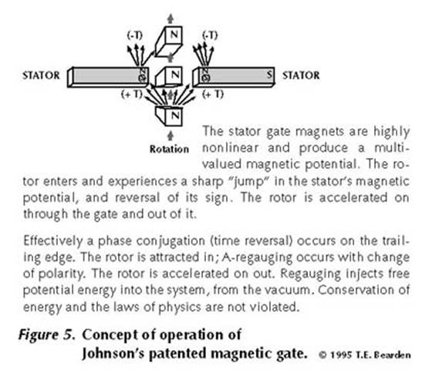

I also found further proof of my experiments from a recent document Howard Johnson released to the web:

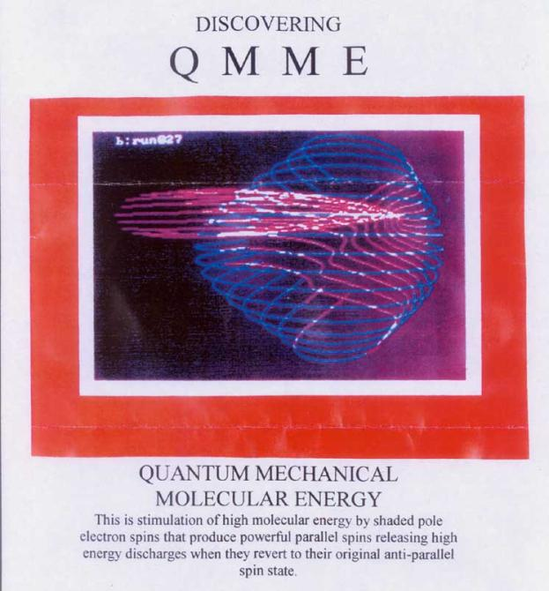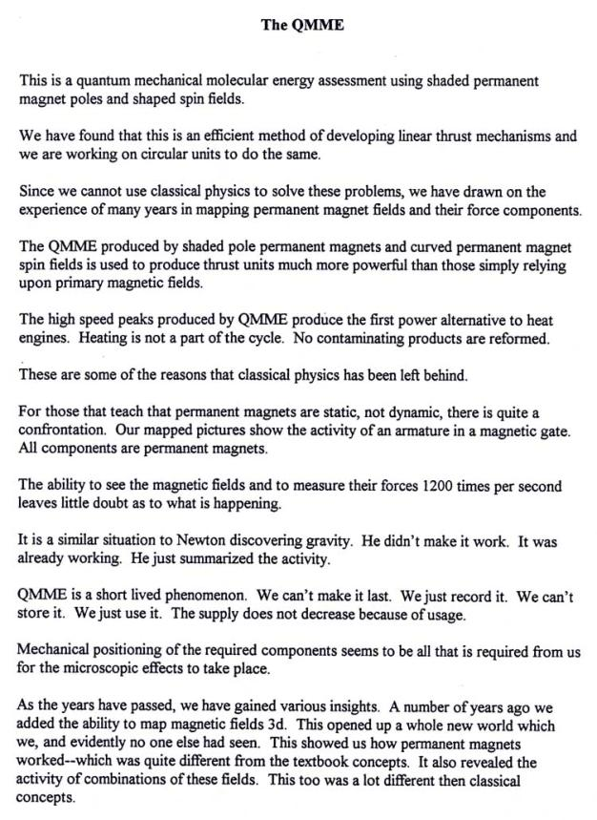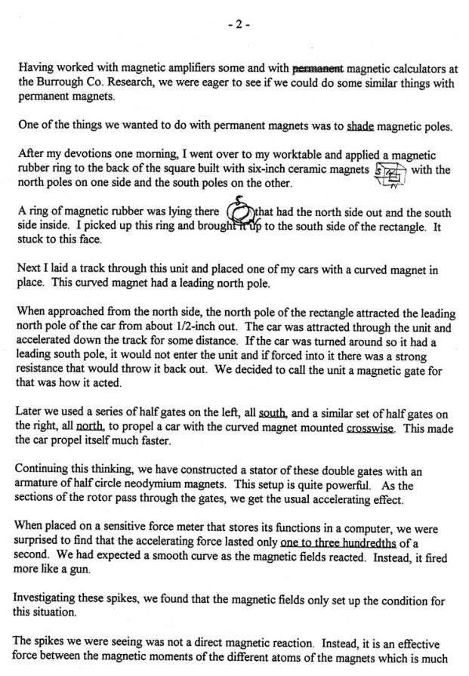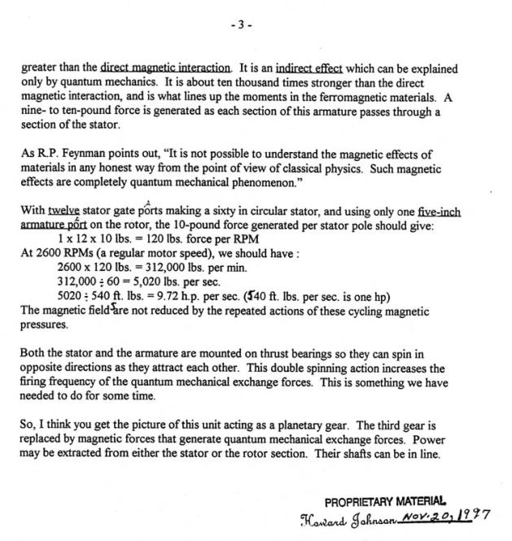
So now, it looks like there is much more going on here than just plain old attraction and repulsion. So if one really wants to truly make a real, functioning magnet motor, it is like anything else, it will take time, patience, and a willingness to do the necessary research to gain a thorough understanding of the subject. Here is a link to another paper written by Tom Bearden, which explains in much more detail what is going on inside magnetic materials. The name of the game is exchange forces and spin effects:

http://www.cheniere.org/correspondence/Johnson%20Motor.doc.

The most relevant information is on the first two pages of this document.

Now, for those less scientifically oriented individuals, I also offer a simple explanation for the 90 degree/multi valued potential scheme. I dub it the “Screen Door Effect.” Consider the following scenario:

Imagine there is a spring-loaded screen door that closes every time someone pushes it open and walks through. If there is a line of people walking through this screen door (one person going through the door every 10 seconds), then as each person pushes the door open to walk through, it closes behind them for the next person to push open.

But let’s say that instead of walking, this line of people started running through that door--meaning one person was passing through it every half second. Since each person is running so quickly through the door, it doesn’t have a chance to close completely before the next person comes through so the people don’t have to push on it as hard (or at all) to go through the doorway. This is like the repel effect we see with the magnets in the 90 degree setup:

As one rotor magnet (a person) passes the stator magnet (the screen door), there is a repel force that wants to keep it from going under the magnet (the force being a person pushing against the door). But as the magnet passes the small repel spot, there is a huge spike of repel force that accelerates the magnet through the gate followed by a small back-attraction force on the other side. In my analogy, my description of how the screen door stays open as the people rushed through it relates to the way the incoming repel force behaves once a bunch of rotor magnets pass by it in succession. The incoming repel force that once acted against the wheel now diminishes as the rotor speed increases leaving only the big positive spike and the back attraction force (which is again much less than the large spike force). Check out the graph again:

With the proper arrangement of magnets, and considerations for the behavior of the magnetic fields, it is then a small matter to construct a running motor. The key is to understand these underlying principles.

I am still learning and experimenting with the basics of magnetics and if the reader is interested in this line of research here are my recommendations.

1. Buy some magnets and play with them. The best way to learn is from a hands-on approach. As I stated above, I encourage everyone to build the arm ramp test so they can feel the forces at work for themselves. Do not simply take my word for it.

2. Do your own research. Look around the web at some of the different models and ideas people present. User groups such as the Minatowheel Yahoo group are excellent places to bounce ideas off people and collaborate. Find out as much about what has been tested so that reinventing the wheel won’t be an issue.

3. Dig into the physics behind the effects. This is where I am currently working. There comes a point where the serious builder needs to acquire a comprehensive understanding of the physics behind magnetic fields. This research is like anything else; you cannot advance it if you don’t know what you are doing. Do your homework.

The more competent experimenters there are working on the subject, the sooner breakthroughs will happen. My goal is to educate people as I make discoveries for myself. Permanent magnet motors can and will soon be a reality. As we all know this world is ready for a change, but the only way that change will occur is through education, experimentation, and dedication.

God Bless,
Jason Owens

